6.71: The velocity and acceleration as functions of time are
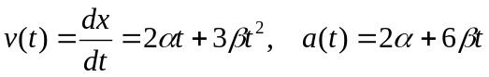
c)

